PCB DESIGN & MANUFACTURING DOCUMENT

RC CAR

1. Scope & Objectives:

Scope

The scope of this project is to design and implement a simple Arduino-based PCB that integrates a battery supply, LED indicator, and push button switch. The PCB is designed using KiCad and includes schematic capture, PCB layout, and 3D visualization.

Objectives

To design a schematic using Arduino UNO R2 module

To create a single-layer PCB

To place and route components correctly

To verify the design using Design Rule Check (DRC)

To generate manufacturing files such as Gerber and BOM

To visualize the PCB in 2D and 3D views

2. Schematic:

UNO R2 (A1) – Acts as the main controller

Battery (BT1) – Provides power supply

LED (D1) – Used as a visual indicator

Push Button Switch (SW1) – Used as user input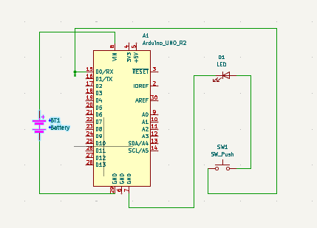

3.PCB Layout-Placement & Routing:

Component Placement

The Arduino UNO is placed centrally for easy access to all pins.

The battery holder is placed at the bottom for mechanical stability.

The push button is placed at the edge of the PCB for easy user access.

The LED is placed near the switch for visual indication.

Routing

Tracks are routed carefully to avoid overlaps.

Power and ground connections are kept short.

Proper clearance is maintained between tracks.

A single-layer routing approach is followed.
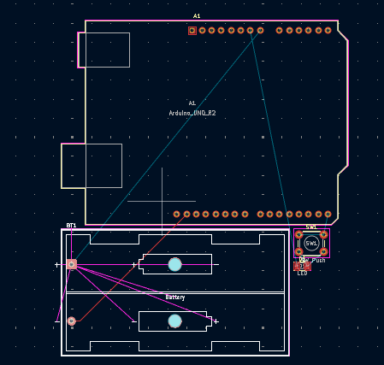

4. Footprint Assignment & PCB Design Rules (DRC):

S.No | Component Name | Reference Designator | Schematic Symbol | Footprint Assigned | Mounting Type
1 | Arduino UNO R2 | A1 | Arduino_UNO_R2 | Arduino_UNO_R2_THT | Through Hole
2 | Battery Holder (2 Cell) | BT1 | Battery | Battery_Holder_2x18650 | Through Hole
3 | LED | D1 | LED | LED_THT_5mm | Through Hole
4 | Push Button Switch | SW1 | SW_Push | SW_Tactile_THT | Through Hole

The minimum track width is maintained at 0.25 mm to ensure safe current flow.

The minimum track clearance of 0.25 mm is provided to prevent short circuits.

The via diameter is set to 0.8 mm, which is suitable for through-hole PCB designs.

The via drill size is maintained at 0.4 mm as a standard drilling value.

A pad-to-pad clearance of 0.25 mm is ensured to avoid solder bridging.

Copper is kept at least 0.5 mm away from the board edge to prevent edge damage.

A silkscreen-to-pad clearance of 0.2 mm is maintained for clear component markings.

The PCB is designed as a single-layer board using one copper layer.

A solder mask clearance of 0.05 mm is provided to ensure proper soldering.

The Design Rule Check (DRC) is successfully passed with no errors or warnings.

Design Rule Check (DRC):

Minimum track width maintained

Proper clearance between pads and tracks

No unconnected nets

No short circuits or overlap errors

The DRC was successfully completed without errors.

5. 2D/3D PCB View & Final checks:

2D View

Shows accurate component placement

Confirms routing correctness

Verifies board outline

3D View

Confirms real-world appearance

Verifies mechanical fitting of battery holder and switch

Helps detect height or placement issues

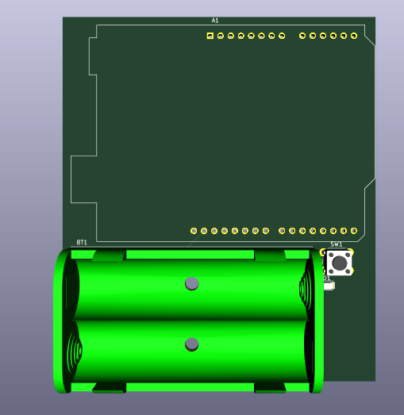

6. Production files(Fabrication & Assembly):

The following files are generated:

Gerber files (Top copper, silkscreen, solder mask)

Drill files

Pick and place files (if required)

BOM file

These files are sufficient for PCB manufacturing and assembly.

6.1 Bill Of Materials (BOM):

S.No | Component Name | Reference | Quantity
1 | Arduino UNO R2 | A1 | 1
2 | Battery Holder (2 Cell) | BT1 | 1
3 | LED | D1 | 1
4 | Push Button Switch | SW1 | 1
5 | PCB Board | — | 1

Bottom of Form

